JAVA AT3
Product Design Specification
Version 1.0
04/12/2020

VERSION HISTORY
The entire Project was developed on Windows over several weeks using Microsoft Word for creating the documents as well as Visual Studio for developing the required application. The entire project used the source control Git to track and control the project.
Version  # | Implemented  By | Revision  Date | Approved  By | Approval  Date | Reason
1.0 | Calvin Moylan | 04/12/2020 | Ken | 04/12/2020 | Initial Design Definition draft
UP Template Version: 12/31/07

TABLE OF CONTENTS
1 Introduction 5
1.1 Purpose of The Product Design Specification Document 5
2 General Overview and Design Guidelines/Approach 5
2.1 Assumptions / Constraints / Standards 5
3 Architecture Design 5
3.1 Logical View 5
3.2 Hardware Architecture 5
3.3 Software Architecture 5
3.4 Security Architecture 5
3.5 Communication Architecture 5
3.6 Performance 6
4 System Design 6
4.1 Use-Cases 6
4.2 Database Design 6
4.3 Data Conversions 6
4.4 Application Program Interfaces 6
4.5 User Interface Design 6
4.6 Performance 6
4.7 Section 508 Compliance 6
5 Product Design Specification Approval 7
Appendix A: References 8
Appendix B: Key Terms 9

Introduction

Purpose of The Product Design Specification Document
The Product Design Specification document documents and tracks the necessary information required to effectively define architecture and system design in order to give the development team guidance on architecture of the system to be developed. The Product Design Specification document is created during the Planning Phase of the project. Its intended audience is the project manager, project team, and development team. Some portions of this document such as the user interface (UI) may on occasion be shared with the client/user, and other stakeholder whose input/approval into the UI is needed. The requirements for the project include:
- Implement your solution
- Must contain a dynamic data structure
- Must contain hashing techniques
- Must contain sorting algorithm
- Must contain searching technique
- Must contain 3rd party library
- Must have a GUI
- Must adhere to coding standards
- Must have help files

General Overview and Design Guidelines/Approach
This section describes the principles and strategies to be used as guidelines when designing and implementing the system.

Assumptions / Constraints / Standards
Assumptions:
I assume that to complete the entire project it will take multiple sessions during class as well as extra work at home.
I assume I will be reusing code that I have already written in previous assessments so I do not have to spent time reinventing the wheel.
I will also be using Git with GitHub to control and deploy my code.
Constraints:
One of the constraints of working with JavaFX in the way I have decided to develop the application in is the fact that there is no way to visualise the design of the application without running it. It also means that I have to programmatically position all GUI controls and view the result when the application runs.
Standards:
I will be following the Java coding convention standards that are outlined here: https://www.oracle.com/technetwork/java/codeconventions-150003.pdf.
Another standard that I will follow is the “Source Control best Practices”. Which can be found here: https://www.atlassian.com/git/tutorials/source-code-management.

Architecture Design
This section outlines the system and hardware architecture design of the application that is being built.
The required application uses CSV files, Comma Separated Values, as its main source of communication. By design, the application itself is not intended to be used with other applications but other programs can make use of the CSV that was outputted from the MP3 Player and use it in its own application. The application will mainly communicate with itself using these CSV files as it will store the song playlist in a CSV and then in the future load that CSV into the application to allow for continuous use.

Logical View
The logical view of the application is the JavaProject class. It will store the Admin username and password inside a hashmap which contains a “User” instance. This user instance stores the username, salt and hashed password to be compared against when logging in. The JavaProject class also stores the user’s playlist which can be exported to the user’s machine and imported back into the application in the future.

Hardware Architecture
The MP3 player requires a minimum:
Keyboard
Mouse
x86 CPU and Supporting Motherboard
Hard drive/SSD.
Without these requirements, the application will not be able to function to the best of its ability or even run at all.
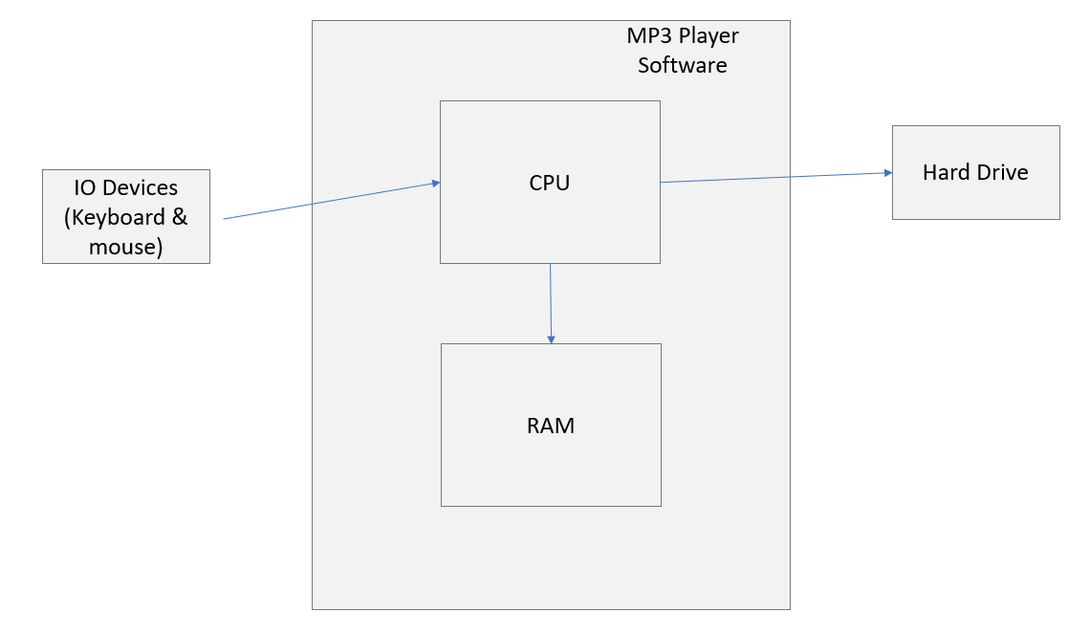

Software Architecture
The project application will have one desktop GUI application which will have everything it needs to meet client requirements. It will securely handle administrator login details by salting the password and then hashing it using a complex algorithm.
It will also include all required music player functionality such as, Save playlist, Load playlist as well as playing the music inside the playlist.
The application will have three main classes, JavaProject class, User class and Hashing class. These are all the classes that are required for the project.
Below you can find the UML of the application:
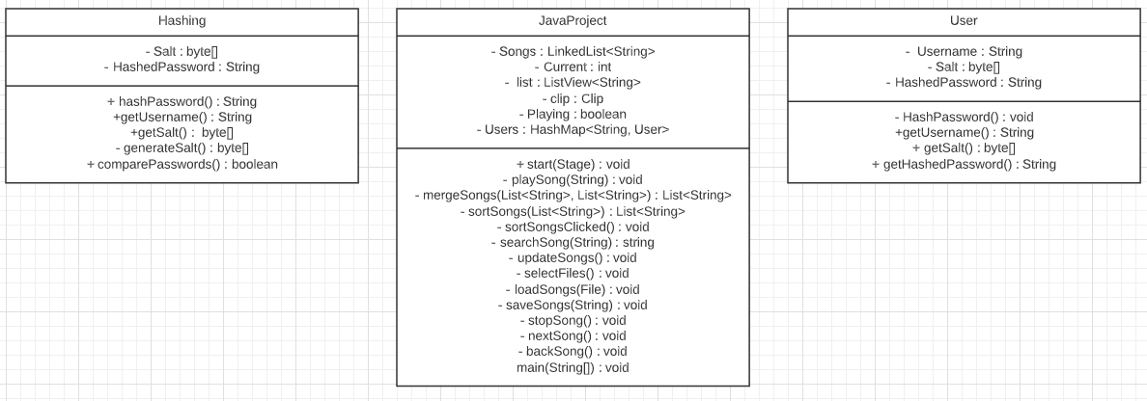

Security Architecture
Security is a crucial part of the application. Since the application must hide information from the average user, it is required I create a username and password login system that is secure and cannot be brute forced. To get around this, I employed hashing and salting the password so that it is as secure as possible. I will use the User and Hashing class to accomplish this. When the user clicks the “login” button, the application will compare the inputted username and password against the existing admin user by applying the same salt and running it through the hashing algorithm to see if it is the same result.

Communication Architecture
The application will include two types of communication present in the application. The first being the user to the application. This includes any command/task that the user asks the application to perform such as inputting the username and password or clicking save playlist.
The other form of communication is when the application exports the playlist to a CSV and imports the playlist from the CSV that the user has created. When importing, the application is reading what it had previously wrote and translates it back into the application using a third-party library.

Performance
The performance of the final application is critical to its success. If the application has frequent and long loading times, the user is not going to have a pleasant time when using the application. Loading times will increase client and user dissatisfaction and may lead to the client choosing a competitor in the future. To reduce these loading times, I have decided to use a fast searching and sorting method, binary search, and merge sort.

System Design

Use-Cases
The user will have access to the full scope of the program, which includes, Add Songs, Skip Song, Back Song, Play and Pause, Load from CSV, Save to CSV, Sort Playlist, Search Playlist and Login.
A diagram of the use cases can be found below:
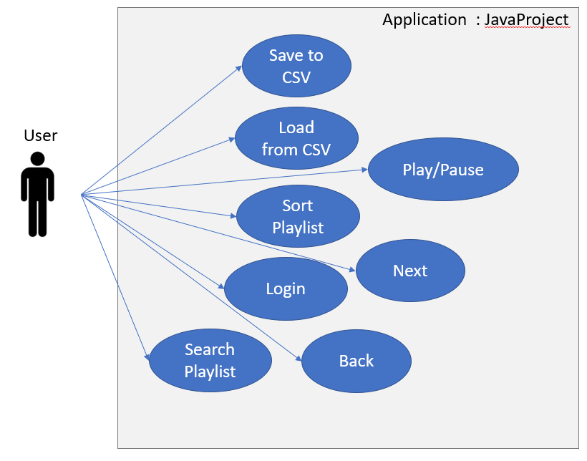

Database Design
The final application will have an internal “database” which will store a hashmap of the User class which will have an instance of the User class which will be the administrator details. This will be stored in the RAM of the target machine.
The application will also use CSV files to store user playlists on the target machine on their hard drive or SSD.

Data Conversions
There are three main data conversions that happen when the application is running. These three conversions happen when the user sorts the song playlist, when the user searches the song playlist and when the user loads a CSV into the application.
Sorting:
When sorting the linked list, I first convert it into an ArrayList of type string. I then break down the list into smaller ArrayLists as per the merge sort algorithm which was the requirement for the task. I chose to do it this way as using a ArrayList type makes it really easy to work with adding and removing data to and from it and to perform the merge.
Searching:
The application takes the main dynamic data structure, the linked list of songs, and converts it into an array of type string. I plan to do it this was as this would be the easiest way for me to work with the data inside the linked list to use the binary sort algorithm. I will not be converting it back into the original LinkedList as I am not updating any data.
Importing CSV:
The application takes the path of the file that the user has selected and then uses the Third Party Library “OpenCSV” to then take that data and import it into the application.

Application Program Interfaces
The application has one interface that is split into two sections/phases. When you first load up the application, it will ask you for a username and password box in which you must enter the correct username and password to continue.
After you successfully login into the application, you will then be presented with the second phase of the application which has all the feature sets that the client has requested such as the music player along with all playlist search, sort, load and save functionality.

User Interface Design
The user interface design was designed to be as easy to use as possible. I followed the “Handy Hints for GUI” which was provided on Programming 3 Blackboard in Session 11-19. I used these tips to help me design a GUI that is simple, consistent, and makes sense when using the application.
I decided to make everything that the user needs visible so there are no hidden features behind a menu that the user has to search for. Everything is correctly placed together and in a spot that makes sense. The application also includes a help button which explains how to use the application.
You can view the prototype design below:
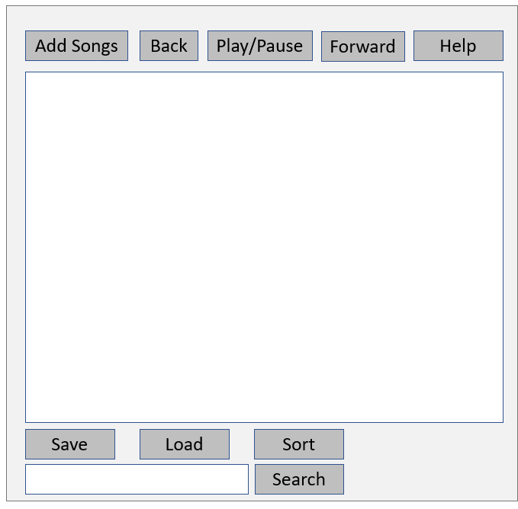

Performance
Performance of the application is critical to its success. The application must be bug and error free and perform at a fast speed.
I have decided to choose Merge Sort and Binary search for the areas in which the application is most likely to slow down due to computing a lot of playlist data and as they were the required algorithms for the project.
These algorithms are fast and allows for the application to scale up and work with larger datasets.

Section 508 Compliance
The Section 508 outlines how an application should look and perform to make it accessible to all users. The section outlines, choosing contrasting colours making it easier for people with lack of vision, large fonts and making text and instructions easy to understand.
I have complied with these as I’ve chosen a simple colour pallet with contrasting colours that will be easy to read as well as making all text at least size 12.
These can be found at: https://www.section508.gov/

Product Design Specification Approval
The undersigned acknowledge they have reviewed the Programming AT3 Project Product Design Specification document and agree with the approach it presents. Any changes to this Requirements Definition will be coordinated with and approved by the undersigned or their designated representatives.

Signature: |  | Date:
Print Name:
Title:
Role:

Signature: |  | Date:
Print Name:
Title:
Role:

Signature: |  | Date:
Print Name:
Title:
Role:

Appendix A: References
The following table summarizes the documents referenced in this document.
Document Name and Version | Description | Location
Java Coding Conventions | The code conventions that must be followed | https://www.oracle.com/technetwork/java/codeconventions-150003.pdf.
Source Control best practices | The standards that should be followed when working with source control | https://www.atlassian.com/git/tutorials/source-code-management.

Appendix B: Key Terms
The following table provides definitions for terms relevant to this document.
Term | Definition
CSV | Comma Separated Values
Hashed/Hash/Hashing | A computed sequence of seemingly random characters that can only be mathematically converted into the characters but not converted from characters to the original text. This is done so passwords can be securely stored inside a database.

